Multimedia
Multimedia information is more than plain text. It includes graphics, animation, sound and video. Multimedia means different things in different circles. One type of multimedia that is becoming a key technology for electronic commerce is digital video. The applications of digital video include video conferencing, video on-demand, and distance education.
The following are the steps that are required for capturing and displaying multimedia objects are:
- Image capture/generation
- Compression
- Storage
- Transport
- Desktop processing and display

- Image capture/generation : The image is captured by a sensor such as a television camera or is generated by an electronic device such as a computers.
- Compression: It is not possible to transfer the complete image through communication media, as it consists of large volume of data. Therefore the data must be compressed using compression techniques that reduces the volume of data without affecting the quality of image.
- Storage: The compressed data are stored on CD-ROM or network storage servers until ready for transport or display.
- Transport: The data representing the image are prepared for transmission. Each component of a video program such as picture, sound, and associated data is separately organized into packets of data. Address and descriptive information is included in each packet. The speed of transmission depends on the characteristics of the medium.
- Desktop processing and display: Once the image is received, the earlier steps are reversed; the bits that were added to aid in transmission are removed.. The video, audio, and data streams for each program are separated. The data stream containing the images may be stored until ready for display. The images are then decompressed and formatted for display on a television, computer monitor, or other appliance.

Multimedia Data Compression
The main purpose of data compression is to decrease the volume of massive data and to eliminate the data redundancy so that the information can be stored on the available storage space that ranges from minimum 2:1 and maximum 200:1. These ranges depend on the desired quality level and various compression/decompression techniques applied.
Compression methods in use include the following:
- Sector-oriented disk compression: Integrated into the operating system, this form of compression is invisible to the end user (e.g., DoubleSpace feature of MS DOS). Another example is the compression of help files in Windows 3.1, which are decompressed on the fly without causing much of a delay.
- Backup or archive-oriented compression: Programs such as PKZIP are often used to compress files before they are downloaded over phone lines or stored on floppy disk.
- Graphics and video-oriented compression: Graphics data in particular can effectively overwhelm any systems on-line storage capability. Compression techniques designed especially for graphics reduce storage requirements by a factor of 100 and can alleviate the flood of data.
- Compression of data being transmitted over law-speed networks: Various compression schemes that are used in modems and routers can be used to reduce the risk of data loss while transmitting them over low speed networks.

Data Compression in Action
Data compression works by eliminating redundancy. Each block of data has an underlying information content, usually expressed as a number of bits. A block of text data containing 1000 bits may only have an underlying information content of 100 bits with the rest being 'white space. The goal of data compression is to make the size of the 1000-bit message as close as possible to the 100 bits of underlying information.
The solution lines in the compression of data. Compression is very important for both data storage and data transmission. Most computer users are familiar with text compression as it applies to saving space on disks. Since an enormous quantity of data (several terabytes) will be sent and received as a result of the various commercial activities on the Superhighway, understanding the various compression approaches is vital.

 |  | Text | Image | Audio | Video
 | Multimedia | ASCU | Bit-mapped | Digitized audio | TV digital
 | Object Type | Plain | graphics, still | or voice | images at
 |  | text | photos, faxes |  | 24-30fps
 | Memory | 2 Kb per | Simple: | Voice/phone,. | 27.7 Mbps for
 | Storage and | page | > 64 Kb/image | 8 kHz/8 bits, | 640*480*24
 | Bandwidth |  | (uncompressed) | 6-44 Kbps' | pixels (24-bit
 | Requirements |  | Detailed: | Audio CD, | color) and 30
 |  |  | >5Mb/image (uncompressed) | 44.1 kHz/16bits, 176 Kbps | fps

Table : Storage and Transmission Requirements for Multimedia.
Compression Techniques
Compression techniques can be divided into two major categories :
- lossy compression and
- lossless compression

These terms refer to the state of a given block of data after it has undergone a complete cycle of compression an decompression. Each is appropriate under certain circumstances.
- Lossy: Lossy compression means that a given set of data will undergo a loss of accuracy or resolution after a cycle of compression and decompression. This type of compression is usually performed on voice, graphics, or video data. Lossy compression often yields a tremendous reduction in space - sometimes on the order of 1000:1. The trade-off for more compression is generally a loss of resolution and clarity.
- Lossless: Lossless compression produces compressed output that is exactly the same as the input. Lossless compression is used on text and numeric data. Text always requires lossless compression because a perfect reconstruction of the original is required. Lossless compression yields approximately a 2 :1 reduction in space.

Lossy compression is by far the more challenging and important because of benefits offered by a high compression factor that can be modified to allow more or less compression of data. While not being able to accurately recreate an exact copy of the input image after compression may sound like an unacceptable compromise, the loss of resolution can be adjusted to be completely undetectable.
Two popular standards for lossy graphics compression are known as MPEG, for the motion Picture Experts Group, and JPEG, for Joint Photographic Experts Group. As the names imply, JPEG is used to compress single graphics images, while MPEG is used for motion pictures.
Multimedia Servers
A server is a hardware and software system that turns raw data into usable information and then provides that information to users when they need it. It captures, processes, manages, and delivers text, images, audio, and video/Electronic commerce applications will require a server to manage application tasks, storage, security, transaction management, and scalability - whereas client devices handle only the user interface aspects, other critical elements are housed in the multimedia server (speed, connectivity, security, and critical applications).
Multimedia server provides a range of platforms that are cheaper, fast and can easily handle new data types. These platforms provide scalability and has the capability for managing multiple concurrent transactions by using multiprocessing, multitasking and multithreading techniques.
1. Multiprocessing
Multiprocessing is defined as the ability to support the concurrent execution of several tasks on multiple processors. This implies the ability to use more than one CPU for executing programs. The processors can be tightly or loosely coupled. In loosely coupled systems, each processor has its own local memory. In tightly coupled systems, a more popular architecture, the processors share common memory. Processors interact with memory using a special memory bus. However, each processor has its own RAM cache, which reduce the traffic on the memory bus. This requires synchronization procedures to ensure that the data in these RAM caches are consistent across the different processors.
The two types of multiprocessing are :
- Symmetric Multiprocessing and
- Asymmetric Multiprocessing

Symmetric Multiprocessing
Symmetric multiprocessing treats all processors as equal; in other words, any processor can do the work of any other processor. Applications are broken down into tasks, processes, and threads, to be run concurrently on any available processor. The goal of this approach is to maximize processor usage or total throughput. A processor does not sit idle if there is work to be done.
Symmetric multiprocessing allows a task to be dynamically assigned to any processor that might be free. This task assignment is usually performed by the network operating system or the server operating system. OS/2 and Window NT are capable of symmetric multiprocessing.
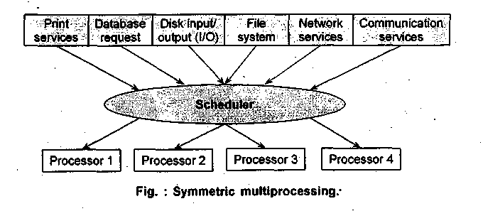
Asymmetric multiprocessing
Asymmetric multiprocessing (ASMP), assigns each task to a specialized processor. Hence, processors work independently relative to other processors. The drawback of ASMP is that tasks are randomly distributed across the available processors. Due to this, other processes have to wait until the execution of previous process is terminated. This restriction is because operating systems have the ability to be executed only a single processor at a time. ASMP lacks scalability, but at the same time provides synchronization since only one process is executed at one time by an operating system.

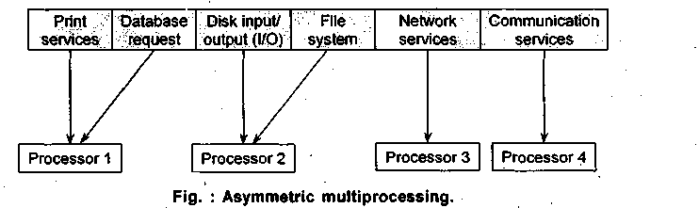
Multitasking
Multitasking means that the server operating systems can run multiple programs and give the illusion that they are running simultaneously by switching control between them.
Two types of multitasking are used :
- preemptive and
- nonpreemptive.
Advanced server operating systems such as Windows NT offers preemptive multitasking, which means that it can distribute CPU time among programs with or without their consent.
1) Preemptive Multitasking: This type of multitasking is present in advanced server operating systems such as Windows NT. Preemptive is defined as a process of preempting the resource before the process is completely executed and distributing the processor's time between the available process with or without their permission.
2) Non-preemptive Multitasking: This multitasking is not possible to preempt the resources until the process is terminated.
Multithreading
Multithreading is a sophisticated form of multitasking and refers to the ability to support separate paths of execution within a single address space (process). Older operating systems achieve multitasking by creating multiple processes, which creates a great deal of overhead. In a multithreaded environment, a process is broken into independent executable task called threads.

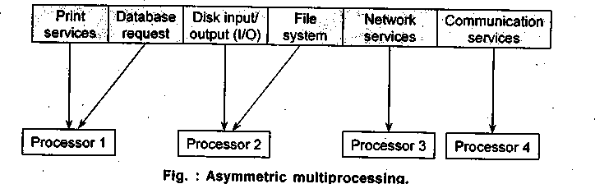

In multitasking, a process is the smallest unit of execution that a system can allocate resources to or schedule to run. A process consists of several threads (paths of execution). In multithreading, a thread is the smallest unit of execution that a system can schedule to run. Each thread consists of a stack, an instruction pointer, a priority queue, a CPU state, and an entry in the system scheduler about its state. The state of a thread can be blocked for input, scheduled for execution, or executing.
Multimedia Storage Technology
Storage technology is becoming a key player in electronic commerce because the storage requirements of modern-day information are enormous. The important characteristic of next generation storage systems is not only the amount of storage but the rate at which data can be read from the disk. In the case of CD-ROM, that rate is currently anywhere from 150 Kbps (single speed) to 60Q Kbps (quadruple speed). This is sufficient for all data but uncompressed, full motion color video.
Storage technology can be divided into two types:
- network-based (disk arrays) and
- desktop -based (CD-ROM).

1. Disk Arrays (Network-based)
Disk arrays store enormous amounts of information and are becoming an important storage technology for firewall servers and other electronic commerce servers. Small arrays run from 5 to 10 gigabytes, and larger systems provide 50-500 gigabytes of storage. The technology behind these disk arrays is call RAID (redundant array of inexpensive disks).
The main point of RAID is that it offers a high degree of data capacity, availability, and redundancy. Current RAID systems use multiple 5 1/2-inch disks to provide what appears as a single virtual disk to the host or the user. RAID achieves availability through the notion of fault tolerance; if something goes wrong, the system will still be able to serve the customers without any downtime. The actual degree of fault tolerance varies depending on the RAID level the user chooses.
RAID technology has many levels. These levels often cause confusion, for not only do we have RAID through RAID 5 but also RAID 5 Plus, 6, and 7. These labels mostly reflect vendor attempts to improve I/O throughput or data availability. At higher levels, users get extremely high data availability (three disks must simultaneously fail for the data to be lost) and increased throughput.

2. CD-ROM (Desktop-based)
The premiere desktop storage technology for electronic commerce applications is CD-ROM. The main advantage and also the prime reason for its success is an incredible storage density that allows a single CD-ROM disc to contain 530 Mb (audio CD) - 4.8 Gb (video CD) of data, compared to 1.44 Mb for the more common 3.5-inch floppy disk. In addition, CD-ROMs are read-only (the data can only be retrieved and no new data can be added). To read the CD-ROMs special drive (the CD-ROM drive) is required.
Two new innovations are breaking into the market: recordable CD, which allows users to repeatedly record and erase digital data, and CD-video, which is expected to replace videocassette movies. In addition to storage benefits, CD-ROM-based electronic publishing is booming because it represents a new avenue of distribution.
CD-ROM technology exhibits the following characteristics:
- High information density. With optical encoding, the CD can contain some 600-800 megabytes of data on a disc less than 5 inches in diameter.
- Low unit cost. Because CDs are manufactured by a well-developed process similar to that used to stamp out LP records, unit cost in large quantities is less than two dollars.
- Read-only medium. CD-ROM is read-only; it cannot be written on or erased. It is an electronic publishing, distribution, and access medium; it cannot replace magnetic disks. But read / write CD technology may be around the corner.
- Modest random access performance. Due to optical read head mass and data encoding methods, random access ("seek time:") performance of CDs is better than floppies but not as good as magnetic hard disks. But performance is improving every year.
CD use a different method to record data compared to analog methods. Analog means that a device actually scribes a pattern of the original wave form onto a recording surface. A separate device, the stylus, physically connects with that surface to "read" the data.
The data are organized into tracks, which may be digital audio or CD-ROM. The process proceeds as follows:
- The CD-ROM spiral surface contains shallow depressions called pits and spaces between indentations called lands. Binary information is encoded by the lengths of these pits and the lengths of the lands. Pits scatter light; lands reflect light.
- The laser projects a beam of light, which is focused by the focusing coil.
- The laser beam penetrates a protective layer of plastic and strikes the reflective aluminium layer on the surface.
- Light striking a land reflects back to the detector and passes through a prism that deflects the beam to a light-sensing diode.
- Light pulses are translated into small electrical voltages that are matched against a timing circuit to generate Is and Os.

Digital Video and Electronic Commerce
Desktop video has changed from an avant garde technology to a practical communication tool in a very short time. Digital video is binary data that represents a sequence of frames, each representing one image. The frames must be shown at about 30 updates per second to fool the eye into perceiving them as continuous (or smooth) motion. Digital video may contain a synchronized sound track.
Figure below shows that digital video is a core component in various electronic commerce applications. Desktop computing power has finally reached the point where you can display images with photographic resolution and color fidelity, play stereo sound to rival a CD, and display video on any monitor.
Characteristics of Digital Video
The following are the several characteristics of digital video :
- CD-ROM have greater storage capacity when compared to other storage technologies.
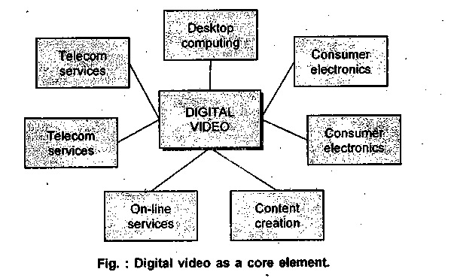
- It allows more flexible routing through packet switching technology
- Digital video enables new applications, such as collaborative planning, that would use multiple senders and receivers.
- Digital video compression technology has enabled the development of new applications in consumer electronics, multimedia computers, and communications markets.
Digital video poses interesting technical challenges. Unlike text or images, video and audio are known as a constant rate, continuous time media. That is, they incorporate an interesting new dimension of data, namely time. The real difference is that video and audio have constant rate outputs requiring audio/visual synchronization that cannot be changed without significantly and negatively impacting the user's ability to extract and understand information. Time is not a crucial factor in text and image understanding, whose temporal nature only comes to life in the hands of the user.

Consumer Market Applications | Communications Market Applications | Computer Market
Digital movie players | Video-on-demand services | Add-in cards for video CD playback
Video karaoke Video games | Cable television channel multiplexing automated | Video game playback High-color image editors
Digital Cameras | ad insertion | Desktop video editing
Digital video cassette recorders | Video telephony | Multimedia presentation authoring
Digital television receivers | Professional video editing | Image databases
Desktop video conferencing | Direct broadcast satellite (DBS) | Color scanners, printers, copiers

Codecs
Codecs is a technique that performs compression and decompression of either video or audio information for storing massive amount of data. Most sophisticated codecs today use lossy compression. This means that some part of the original image is lost during compression. Because they use lossy compression, codecs have a wider selection of data-shrinking techniques available to them and can achieve much higher compression ratios than lossless technology.
Types of Codecs
Most codec schemes can be categorized into two types:
- hybrid and
- software-based

1. Hybrid Codec
Hybrid codecs use a combination of dedicated processors and software. In general, the best compression ratios are enabled by complex algorithms that require significant processing power. This power can be attained only by using dedicated hardware chips or boards. The problem with hybrid codecs is that they require specialized (and expensive) add-on hardware in the playback computer in order to work.
This cost requirement has kept MPEG growth on the desktop slow, but hardware vendors have become interested in bringing MPEG devices to market as the processor speeds, local buses on motherboards, and high-speed CD-ROM drives have nudged the average system onto a new tier of performance.
Three hybrid standards are used :
- JPEG for compression of still images,
- MPEG I for compression of video to CDs, and
- MPEG II for compression of video in real time.

These standards specify the syntax in which the compressed data must be presented for multi-vendor equipment compatibility, but they do not specify the specific compression methodology. Thus, although image compatibility was obtained with the standards, image quality and compression efficiency were not addressed. Therefore, different compression solutions may be able to share video data, but there may be differences in quality and cost.
I) JPEG: Developed by the Joint ISO / CCITT Picture Experts Group based on a file compression / decompression algorithm for individual still images.
2) MPEG-1 andMPEG-2: Open standards developed by the ISO / CCITT Moving Pictures Experts Groups for providing digital motion video with sound.
Two basic types of compression are done in a video sequence are
- intraframe and
- interframe
Intraframe - As the prefixes imply, intraframe techniques compress a frame using only the data contained within that frame. Intraframe compression is generally used to generate periodic "key" frames that provide sanity checks on the compressed output compared to the original video.
Interframe - Interframe compression generates compressed frames that are based on only the differences between two frames, otherwise known as delta frames (i.e. the characters are running, but the background scenery remains the same). Whereas some lower-quality codecs may use only one of these techniques, recent codecs use both.
Moving Pictures Experts Group (MPEG)
Moving Pictures Experts Group is ah ISO (the International Standards Organization) group whose purpose is to generate standards for high-quality compression of digital video (sequences of images in time) with sound. When the MPEG began its work to develop a standard for digital video compression, its goal was to develop an algorithm that could compress a video signal and then be able to play it back off a CD-ROM or over telephone lines at a low bit rate (less than 1.5 Mbps). The goal was to achieve a quality level that could match that of a VHS video tape. Two standards have been defined by the committees are MPEG-1 and MPEG-2.
MPEG-1
MPEG-1 defines a bit stream for compressed video and audio optimized to fit into a bandwidth (data rate) of 1.5 Mbps. This rate is special because it is the data rate of (uncompressed) audio CDs and DATs.
The standard consists of three parts - video, audio, and systems - where the last part gives the integration of the audio and video streams with the proper time stamping to allow synchronization of video and audio.
The MPEG-1 implemented in commercial chips allows users to compress and play back MPEG-1 video. C-Cube Microsystems, the leader in manufacturing chips for the MPEG standard, supplies the chips on most of the MPEG video cards on the market. The MPEG-1 standard is primarily intended to process video at SIF (source input format) resolution: 352 x 240 pixels at 30 frames per second. This is one-fourth the resolution of the broadcast television resolution standard (CCIR 601), which calls for 720 x480 pixels.

The quality of decompressed digital video is measured by the number of displayable colors, the number of pixels per frame (resolution), and number of frames per second. Each of these elements can be traded off for benefit of another and all can be traded for better transmission rates, but it is impossible to combine all of them at the television broadcast quality at low transmission speeds.
MPEG-2
A second MPEG specification, known as MPEG-2, compress signals for broadcast-quality video. The interest in broadcast digital video is apparent. With the work of the MPEG-2 complete, many companies with proprietary compression schemes are now becoming deeply involved in bringing their technology in line with the rest of the industry.
MPEG-S incorporates a compression algorithm that processes video at full resolution, even at low data transmission rates. This second phase of the MPEG work concentrates on optimizing the specifications for the needs of broadcasters by providing better performance, fully supporting interlaced video sources (which were not supported in the first algorithm) and, driven by semiconductor advances, lower manufacturing costs to meet the price range of consumer set-top decoders.
Technically, MPEG-2 specifies the coded bit stream for high-quality "entertainment-level" digital video.
Joint Photographic Experts Group (JPEG)
JPEG is a still-image compression algorithm defined by the Joint Photographic Experts Group and serves as the foundation for digital video. JPEG is used in two ways in the digital video world: as a part of MPEG or as motion JPEG. In both these methods, each image frame is compressed as though it were a still image.
The JPEG standard has been widely adopted for video sequences because its compression chips are relatively inexpensive and motion JPEG allows easy access to any frame in a digitized sequence. JPEG compression is fast and can capture full-screen, full-rate video, although the image degrades noticeably if the compression exceeds 20:1.
JPEG was designed for compressing either full-color (24-bit) or gray-scale digital images of "natural" (real-world) scenes.
2. Software-based Codec
The two types of software-based codecs are :
- Cinepack and
- Indeo
These software-based codecs are grouped together to be used in video application software like QuickTime and Microsoft Video for Windows.

- Cinepak: Cinepak performs well with motion videos and is widely used for distributing movies on CD-ROM. Like MPEG, Cinepak is an asymmetrical codec, which means that while compression is fairly slow (about half an hour per minute of video compressed), playback is very quick and efficient. Cinepak can easily play 15 fps of video back in a 320 x 240 pixel window and still stay within the lowest common denominator of CD-ROM transfer rates - 150 Kbps.
- Indeo: Intel's Indeo is a symmetric codec that spends an equal amount of compression and decompression time. Indeo is becoming a major player in video conferencing, a technology that requires real-time compression and decompression.
Recent versions of Indeo had problems with performance and compression ratios between key frames (intraframe compressed) and delta frames (interframe compressed). Indeo 4.0 version greatly improved performance and transfer-rate requirements and may have a bright future in the CD-ROM world.
Video on the desktop is a key element in turning a computer into a true multimedia platform. The various components that are required for processing and production of digital video are:
- Video capture hardware
- Video playback accelerator boards
- Editing software
- Desktop video appl ication software

The peripheral device that are required for processing digital video are:
- Microphones
- Speakers
- Joysticks

1. Desktop Video Hardware for playback and Capture
The basic requirement for capturing and processing digital video are :
- Large amount of disk space
- Significant speed of CPU processor
- Specialized hardware that performs digitizing and compressing of the incoming video signals.
Earlier it was very difficult to process video because of large volumes of data present in it.
This problem is solved by using products of video playback that improved the capability of a system responsible for processing multimedia. The two video playback products are :
- Video ASIC (Application specific integrated circuits)
- Board level products

These improve the ability of PCs to carry multimedia. Both chips and board products can be integrated into the PC, and board products are installed into the PC as a separate card.
2. Video Playback Accelerator Boards
A video board enables a PC to display full motion video on the computer screen. Effectively, it converts the signal from one form to another, as the video display for television is different from that of the computer. Most video boards also incorporate basic sound capabilities, enabling them to behave almost like a TV.
The two types of accelerator boards available are :
- Graphics accelerator board and
- Video accelerator board

- Graphics accelerators - These accelerators concentrate on moving graphics data (e.g., GIF and JPEG files) as swiftly as possible from the display adapter's on-board DRAM or VRAM (dynamic and virtual random access memory) to the computer monitor. These adapters incorporate graphics acceleration processors; the chips use on-board 32- and 64-bit data paths to speed graphics data.
- Video accelerators - These accelerators improve the playback speed and quality of captured digital video sequences, and in most cases their only goal is to improve motion-video playback. Same as graphics processors, video processors exist for enhancing playback of digital video.

3. Video Capture and Editing
Video capture boards are essential for digitizing income video (NTSC, PAL, S-Video) for use in multimedia presentations or video conferencing. Video capture boards are also responsible for handling interpolation tasks in resizing images and sending the VGA and video signals out to the monitor so that users can see what is happening.
Once the incoming raw video is digitized, it is handed over to the video compression board via an internal connector. The compression board may use a variety of compression methods (MPEG, Motion-JPEG, Indeo), depending on the manufacturer. The video capture program also includes video-editing functions that lets users crop, resize and convert formats and add special effects for both audio and video such as fade-ins, embosses, zooms, and echos.
Developers are creating next generation video-editing tools designed to meet the wide-ranging needs of professional producers, business presenters, and video enthusiasts.
The video capture software for compression and playback is a key ingredient for creating application assets that are usable on multiple platforms. Cross-platform development is the process of capturing, editing, compressing, and converting digital video files for playback on diverse platforms and environments supporting the chosen video standard. After creating video content, the developer has the choice of using QuickTime or Video for Windows to create an end-user application.
4. Desktop Video Application Software
Computer that wants to handle digital video must have a digital-video engine available. Two significant desktop digital-video engines are:
- Apple's QuickTime (and QuickTime for Windows) and
- Microsoft's video for Windows.
QuickTime and video for Windows are "software only," meaning that no special hardware is required to playback digital movies. Although hardware-assisted playback is possible, few desktop computers are outfitted with the necessary hardware.
Apple QuickTime
QuickTime is a set of software programs from Apple that allows the operating system to play motion video sequences on a PC without specialized hardware. QuickTime has its own set of compression/decompression drivers (codecs), similar to those found in Video for Windows, and plays video files with the MOV extension.
QuickTime is a leader in many ways for desktop video; it plays the same role that PostScript played for print publishing. Few users would want to look into the data structures of a QuickTime file, but everyone appreciates what it offers: resolution and device independence, multivendor support, and a standard interface between system components.
QuickTime was the first widely available desktop video technology to treat video as a standard data type.
The various features that are incorporated in digital video using QuickTime are :
- One such feature is multiple tracks. A QuickTime movie can have multiple sound tracks (for example, in different languages) and multiple video tracks (helpful in video editing)
- QuickTime also supports synchronized text (subtitles) that can appear in the movie.

Microsoft's Video for Windows
Video for Windows is a set of software programs from Microsoft that allows Windows to play motion video sequences on a PC without specialized hardware. Video for Windows has its own set of compression / decompression drivers (called codecs), similar to those found in QuickTime for Windows, and plays video files with the AVI extension, short for Audio/Video Interleaved.
Microsoft chose a frame-based model, in contrast to QuickTime's time based model, which limits Video for Windows to a subset of QuickTime's features. For example, you can't have a frame (or group of frames) remain on the screen for a variable amount of time with Video for Windows as you can with QuickTime.
Desktop Video Conferencing
The increasing digital video capabilities of PCs, desktop video conferencing is gaining momentum as a communication tool. For many business users, face-to-face video conferences are already a common practice, allowing distant colleagues to communicate without the expense and inconvenience of travelling.
Early video conferencing utilized costly equipment to provide room-based conferencing in which all participants at a location gather in a specially equipped conference room and view monitors displaying similar rooms at remote sites.
Three factors have made desktop video conferencing a viable solution for business and personal communications today:
- Price: The cost of video conferencing equipment has fallen dramatically. Digital video capture and playback boards and enabling better capture and processing of desktop video at a very low price.
- Standards ; A worldwide standard for video conferencing is slowly emerging, allowing interoperable communications between machines from different vendors.
- Compression: Bandwidth has traditionally been the limiting factor (or bottleneck). Sending video through a communications channel requires a lot of bandwidth. Better and faster compression methods are reducing the overhead associated with video conferencing.
Video conferencing is quickly leaping from corporate systems to desktops. By leveraging the power of faster processors along with new advancements in video-, sound-, and data-compression techniques, vendors have introduced packages that turn PCs into videophones. Once the PC is equipped, users can place long-distance video calls over regular POTS lines for the price of a regular telephone call.
Viability does not mean widespread usage, however. Because video conferencing requires significant investments in equipment and technical skills and often entails the use of dedicated facilities with special communications lines, its applicability and appeal to business have been limited.
Data or Document Conferencing
Data conferencing is a form of screen sharing. Instead of having full control of a local system a remote user shares one or more designated windows with a local user. Most solutions use a whiteboard model. After establishing a desktop-to-desktop connection* the session presents a whiteboard software includes drawing, painting, and annotation tools for brainstorming and sketching, enabling users to emulate the interactive discussions that often take place in real meeting rooms. Bitmaps of the whiteboard are compressed before being sent over the wire, and users can save snapshots of the whiteboard for future reference.
The next step in terms of capabilities is interactive file or application sharing. Here, the user selects a window or file that a remote partner can access, and then both can review and modify the document. The main advantage is that both users can directly modify source data.
Various technical approaches can be used to enable application sharing. One approach captures the Windows GDI (Graphical Device Interface) screen drawing commands and sends these commands over the phone line to the receiving system, where they are executed in the background transparent to the user. Sending drawing commands and not images makes efficient use of the communications bandwidth while granting the remote and local users access to the same screen.
Types of Desktop Video Conferencing
The three ways by which desktop video conferencing is made possible are by using :
- Plain old telephone lines (POTS)
- Integrated service digital network (ISDN)
- Internet

1. Using POTS for Video Conferencing
POTS systems are especially attractive for point-to-point conferencing because no additional monthly charges are assessed and special arrangements with the phone company are unnecessary. The drawback with a POTS solution is a restriction to the top speed of today's modems 28.8 Kbps to transmit all the multimedia data.
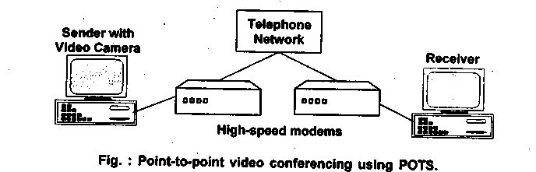

Most POTS solutions come complete with an external 28.8-Kbps V.fast fax/modem, a color video camera, a combination earpiece/microphone, and two expansion boards. One board captures and compresses the outgoing video. Incoming video is often decompressed through software, relying on the system's CPU horsepower. The other card is a communications board for handling audio compression and decompression.
Once properly installed, the video conferencing software allows users to pipe video, audio, and data down a standard telephone line. So making a video conference call is as easy as making a phone call. An on-screen keypad is used to dial the number, and the system is flexible enough to allow the call recipient to answer on a regular telephone, then switch over to his or her own system. There's no need to call in advance to set up the video conference. Most packages also offer full application sharing, as well as a whiteboard that enables you to scan in any document so that you can edit the image together over the phone. A snapshot utility also allows users to take quick pictures, then highlight certain areas or attach electronic sticky notes.
2. Using ISDN for Video Conferencing
Figure below shows the basic architecture for tele or video conferencing using ISDN network transport and switching. This architecture is commonly found in videophones. The videophone is essentially a scaled-down, limited functionality, residential video conferencing service. Videophone combines a voice telephone with a video camera and monitor in a single desktop unit. Network requirements for the videophone are mainly fiber optic cable or analog POTS.
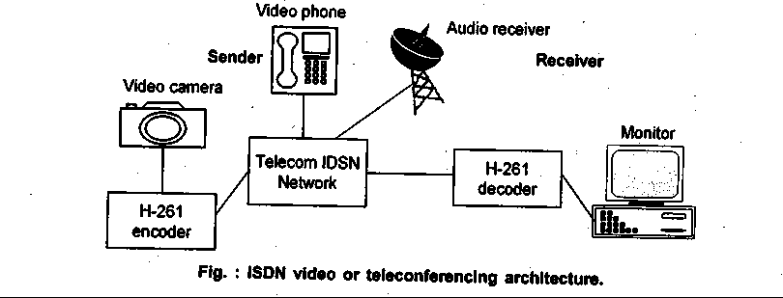

For video compression and decompression, the ISDN network uses the H.261 video compression technology. The International Telegraph and Telephone Consultative Committee (CCITT) has specified the H.261 video transmission protocol for use in real-time video information delivery at bandwidth increments of 64 Kbps.
The image quality delivered by H.261 increases with bandwidth and supports so-called graceful degradation. This term refers to the behavior of a system using a packet-switched channel that is heavily loaded. Some compression schemes, including H.261, use a scheme that sends very coarse information about the video picture across the channel first, then successively refines the picture if it has enough bandwidth left to do so. Others do things like starting from the top of the picture and leave it incomplete if time runs out. That can be very annoying.
3. Using the Internet for Video Conferencing
Two video conferencing programs are available on the Internet:
- CU-SeeMe and
- MBONE
CU-SeeMe
CU-SeeMe is the first software available for the Macintosh and Windows platforms to support real-time multiparty video conferencing on the Internet. CU-SeeMe provides a one-to-one conference, or by use of a reflector a one-to-many, a several-to-several, or a several-to-many conferencing depending on user needs and hardware capabilities. It displays 4-bit gray-scale video windows at 160 x 120 pixels (postage stamp-sized) and also includes audio.
CU-SeeMe is intended to provide useful conferencing at minimal cost. Receiving requires only a Mac with a screen capable of displaying 16 grays and a connection to the Internet. Sending requires the same plus a camera and digitizer.
A digital camera, such as a 4-bit gray-scale camera, that attaches to the Macintosh's serial port is a requirement for sending video. In addition to the point-to-point conferencing, CU-SeeMe allows one-to-many broadcasts using the notion of a reflector. Users can dial into a particular computer on the network designated as a reflector and receive the broadcasts that emanate from that site.
MBONE
The MBONE is a virtual network that has been in existence since early 1992. It originated from an effort to multicast audio and video from meetings of the Internet Engineering Task Force. The MBONE shares the same physical media as the Internet. It uses a network of routers (mrouters - multicast routers) that can support IP multicast. MBONE set-up is not for the faint of heart and is time consuming because a lot of learning and fixing are involved. However, all the tools are documented, and help is available from the MBONE community.
MBONE is composed of islands that support IP multicasting to local clients These islands are connected by virtual point-to-point links called tunnels. Routing software called mrouted (multicast routed) has been developed to let UNIX workstations act as multicast routers. Between these routers, the multicast IP packets are tunneled (encapsulated into regular IP packets) with the mrouted machines as destination sites.

